Project Design Phase-II
Technology Stack (Architecture & Stack)

Date | 20 February 2026
Team ID | LTVIP2026TMIDS41306
Project Name | Plugging into the Future: An Exploration of Electricity Consumption Patterns Using Tableau
Maximum Marks | 4 Marks

Technical Architecture:
The deliverable shall include the architectural diagram as shown below along with the details specified in Table 1 and Table 2.
Example: Electricity consumption analysis and visualization for efficient energy planning using
Tableau.Reference:https://developer.ibm.com/patterns/ai-powered-backend-system-for-order-processing-during-pandemics/
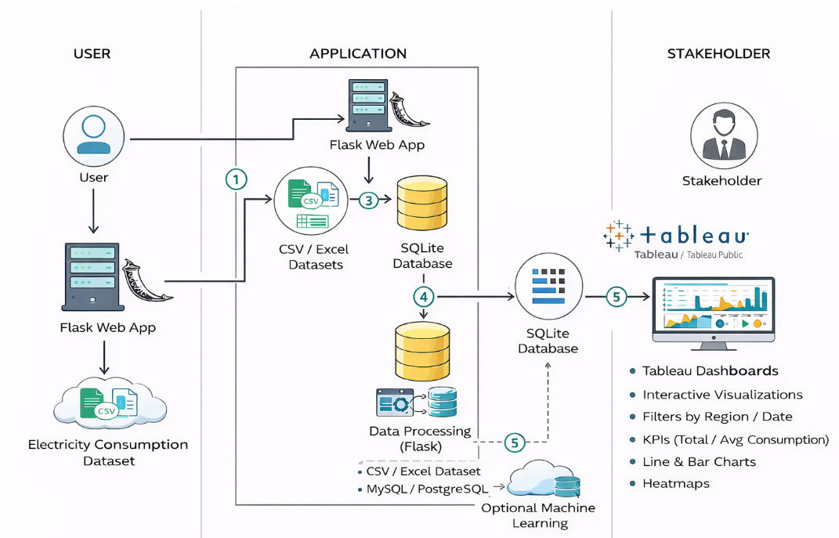
Guidelines :
The architecture diagram should include all major application logic and technology blocks involved in the electricity consumption analysis system. Clearly demarcate the infrastructure into Local/User environment and Cloud/Data processing environment. Indicate any external interfaces, such as data sources or APIs used for electricity datasets. Show data storage components/services used to store raw and processed electricity consumption data. If applicable, include the interface to analytics or machine learning models used for trend analysis, peak demand detection, or forecasting, and their integration with Tableau for visualization.

Table-1 : Components & Technologies:
S.No | Component | Description | Technology
 | User Interface | Interface for users to view dashboards and  interact with reports | Tableau Dashboard, Web Browser  .
 | Application Logic-1 | Data cleaning and preprocessing logic | Python (Pandas, NumPy)
 | Application Logic-2 | Data analysis and aggregation logic | Python
 | Application Logic-3 | Data visualization and reporting logic | Tableau
 | Database | Stores historical electricity consumption data | CSV / Excel / Relational Database
 | Cloud Database | Centralized storage for large datasets (if deployed  on cloud) | AWS RDS / Google BigQuery / Azure  SQL (optional)
 | File Storage | Storage for raw datasets and processed files | Local File System / Cloud Storage
 | External API-1 | Weather data used to analyze impact on electricity usage | Weather API
 | External API-2 | Government / public electricity consumption datasets | Open Data API
 | Machine Learning Model | Used for demand forecasting and trend prediction (optional) | Python (Scikit-learn)
 | Infrastructure (Server / Cloud) | Platform used to run analysis and dashboards | Local Machine / Cloud Platform

Table-2: Application Characteristics:
S.No | Characteristics | Description | Technology
 | Open-Source Frameworks | Libraries and tools used for data analysis | Python, Pandas, NumPy
 | Security Implementations | Tool used for interactive dashboards | Tableau
 | Scalable Architecture | Ability to handle large datasets | Cloud Storage, Tableau
 | Availability | Data access control and secure storage | Role-based access, Cloud Security
 | Performance | Efficient processing of large electricity datasets | Optimized Python scripts

References:
https://help.tableau.com
https://www.tableau.com/learn
https://pandas.pydata.org/docs/
https://numpy.org/doc/
https://aws.amazon.com/architecture/

